NY SHIELD Act Compliance for Log360
Strengthen cybersecurity and meet NY SHIELD Act compliance with Log360.
Region: USA | Type: Industry Standard | Category: Compliance | Pricing: Free

Overview
The NY SHIELD Act compliance extension in Log360 helps organizations meet the New York SHIELD Act, a New York State law requiring businesses handling NY residents' private information to implement data security programs with administrative, technical, and physical safeguards by providing centralized log management, threat detection, and real-time security monitoring. The platform supports NY SHIELD Act requirements for security program management, risk assessment, access control, network security monitoring, endpoint protection, data disposal auditing, breach detection, and third-party provider oversight.
For Administrative Security Program Management, Log360 audits policy changes, group membership updates, and GPO configurations to verify administrative controls are documented and enforced. To address Risk Assessment and Employee Security Training, the platform provides system event, computer auditing, and user activity monitoring to support risk identification and verify employee compliance with security procedures. The extension also supports Access Control and Authentication by providing capabilities that monitors Windows and Unix logon events, failed access attempts, Active Directory logon records, and network device logon activity to enforce access controls over private information.

Key Features
- Network Security and Attack Detection: Log360 monitors network device rule changes, configuration updates, attack reports, and firewall policy compliance to protect private information network infrastructure.
- Endpoint Protection and Threat Response: Log360 tracks Windows and Unix threat detection, malware events, endpoint protection alerts, and application whitelisting to maintain effective endpoint defenses.
- Physical Security and Data Disposal Controls: Log360 audits removable disk usage, USB storage events, file modifications, and cloud storage activity to enforce data disposal and physical controls.
- Breach Detection and Notification: Log360 monitors network attacks, threat detection events, malware alerts, and risky sign-in activity to detect breaches that trigger mandatory notification obligations.
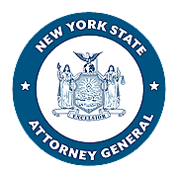
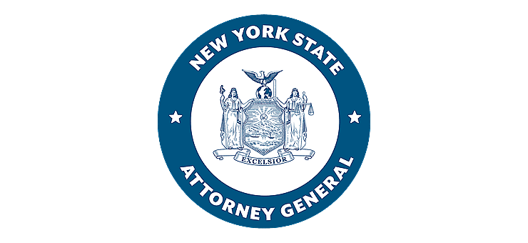
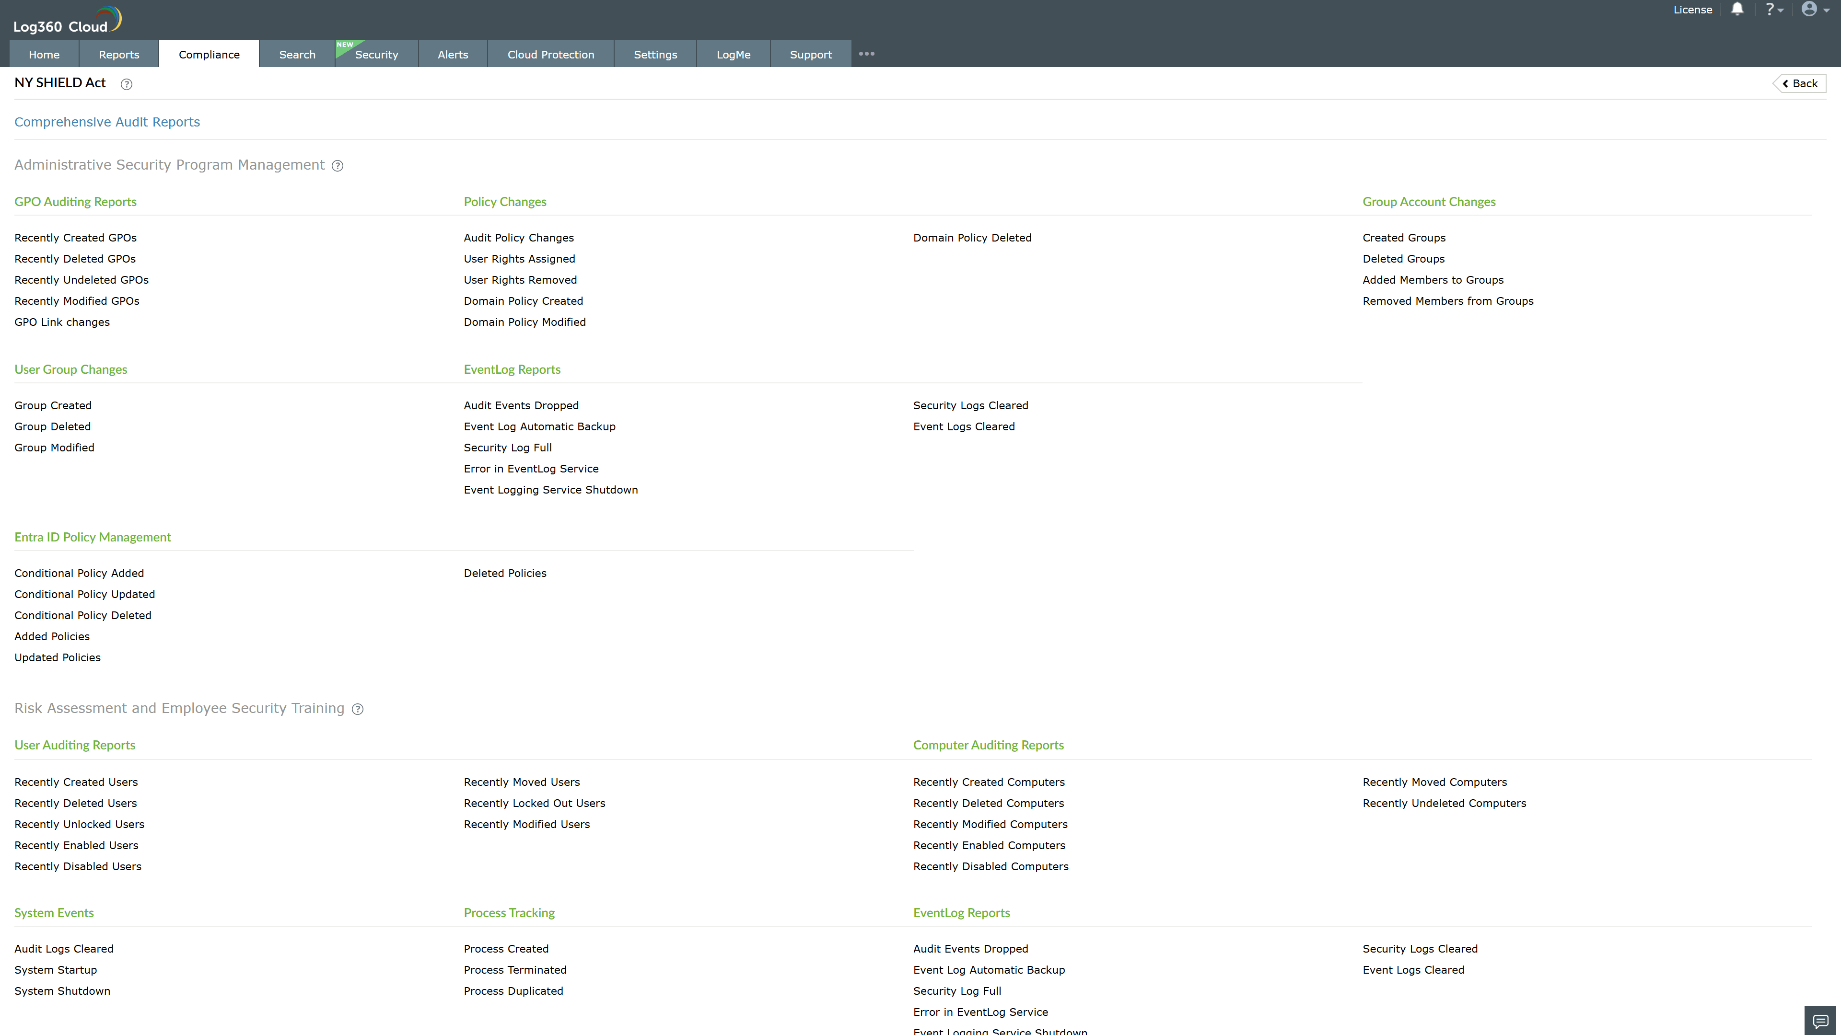
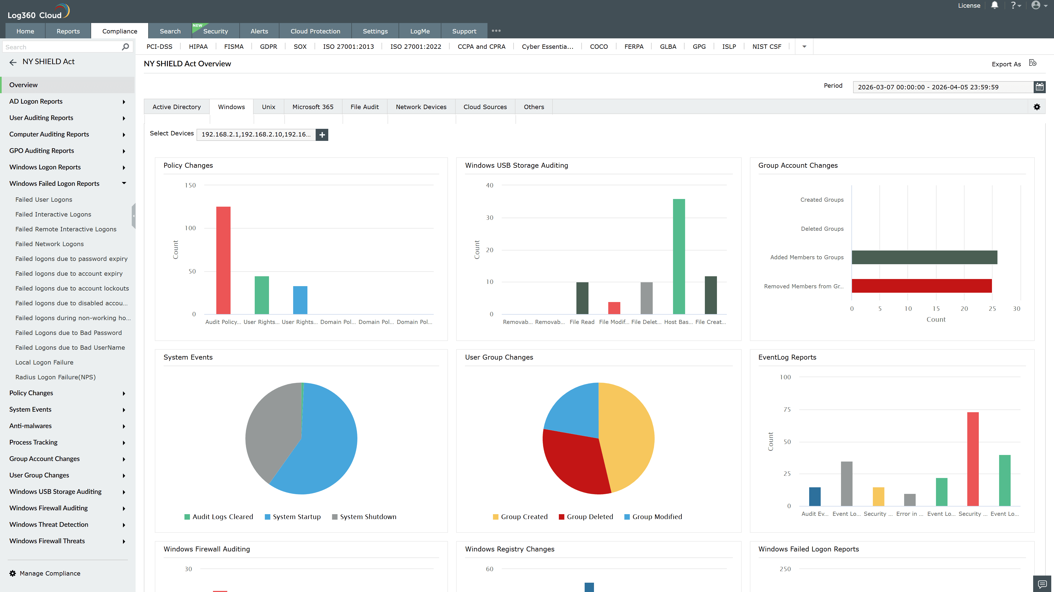
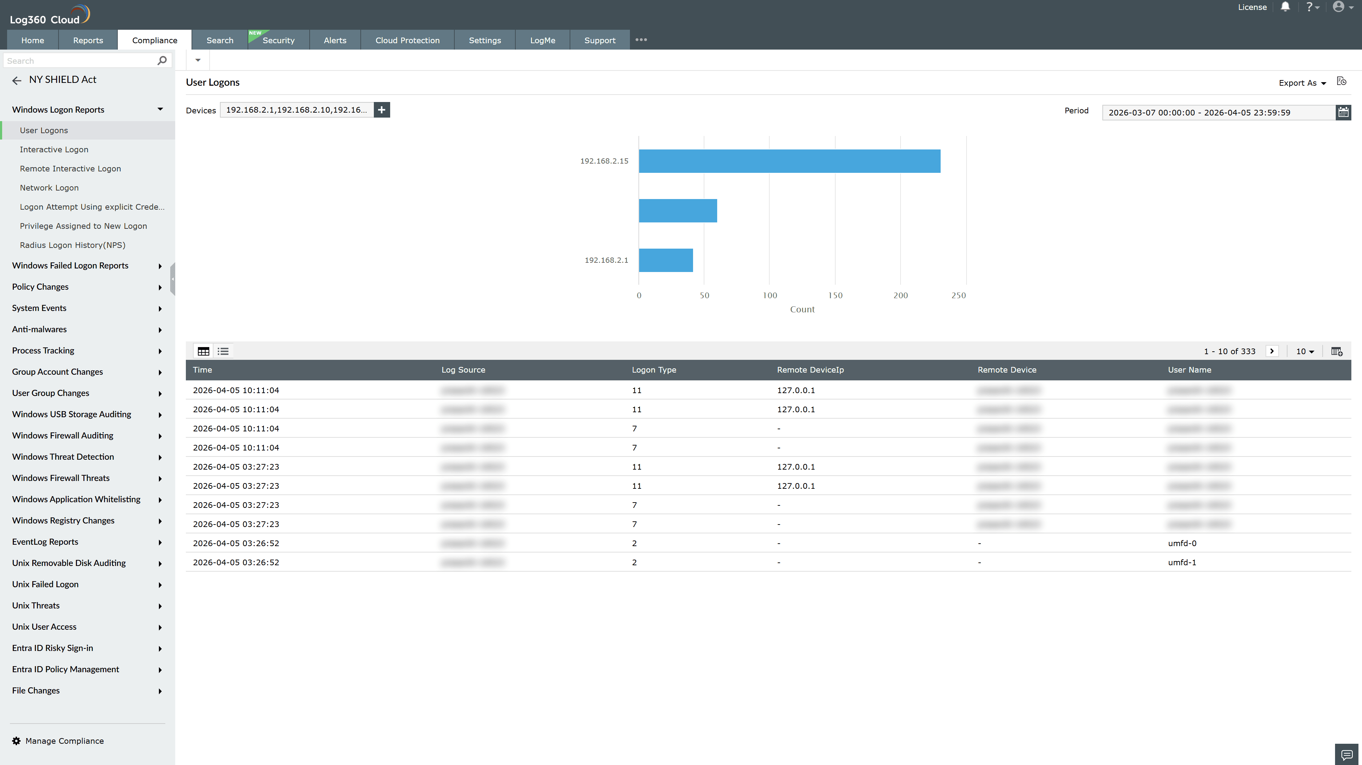
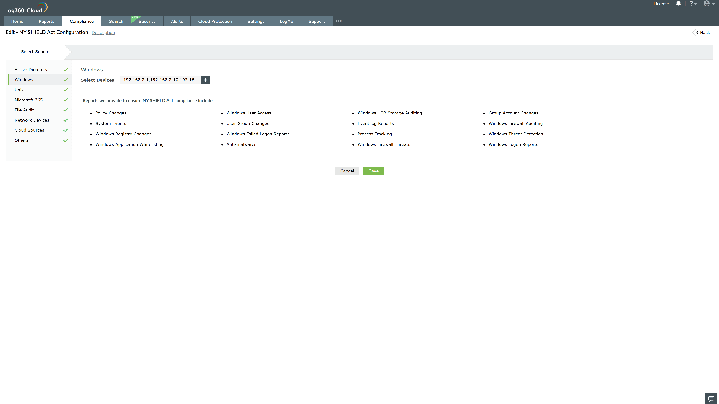
Valid Submission : Yes
Supported Editions : Free, Basic, Standard, Professional, MSSP
Help Document : https://www.manageengine.com/log-management/help/integrations/compliance-extensions.html
Help Video : Not provided
Tags : Log360, Compliance, Privacy monitoring, Data privacy, Regulatory compliance
Supported DCs : US, IN, JP, CA, AU, UK and EU
Privacy Policy:
Terms of Service:
Release Notes:
Predefined reports for the NY SHIELD Act.

